Given the root of a binary tree, return *an array of the largest value in each row* of the tree **(0-indexed)**.

**Example 1:**

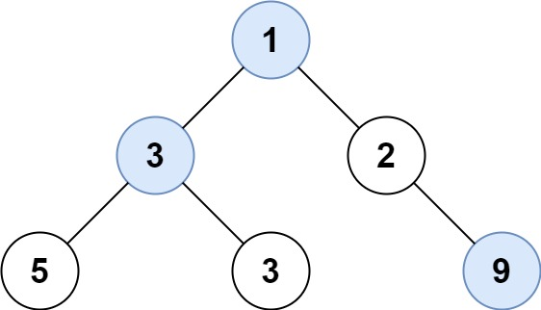

Input: root = [1,3,2,5,3,null,9]  
Output: [1,3,9]

**Example 2:**

Input: root = [1,2,3]  
Output: [1,3]

**Constraints:**

* The number of nodes in the tree will be in the range [0, 104].
* -231 <= Node.val <= 231 - 1